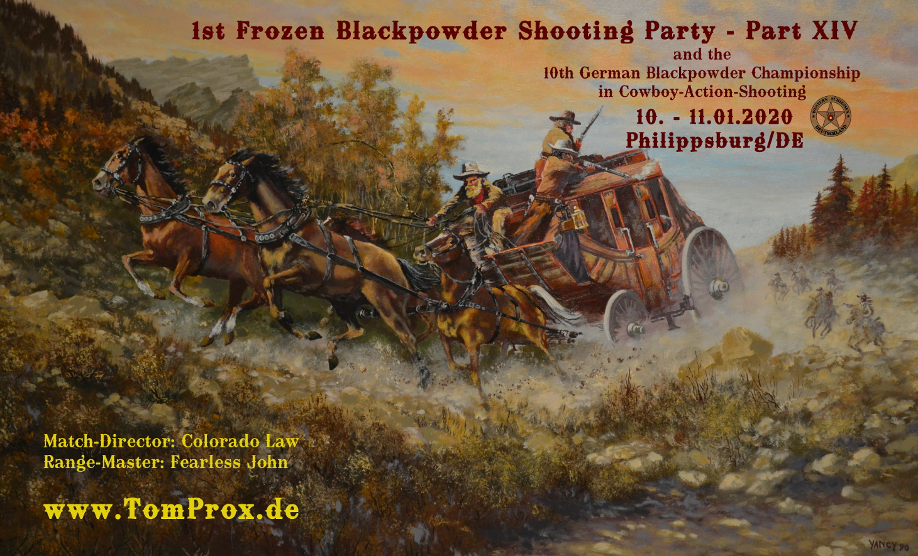

12 Stages Cowboy Action Shooting
Categories are recognized as mentioned below
max. 80 participants
(Confirmation only after payment of Match Fee)

Start: Friday + Saturday 09:00 AM Mainmatch 6 Stages
Friday at 8:30 AM: Matchbriefing (obligatory)
Friday after Mainmatch: Sidematch “Plainsman” 2-3 Stages
End of Shooting: Friday at 3:30 PM Saturday at 3:30 PM

Main Match Fee: 50 € via Bank Transaction together with the Application/Registration.
Young Guns: 25 €
Deadline Registration: Sunday, December, 31, 2019
Match Director: Dieter Schramm „Colorado Law“
Range Master: Hans-Richard Schuhmacher „Fearless John“
Organizer: Rainer Bott “Tom Prox”
Guns and Ammo: see at “Information”
Outfit: Cowboy correct costuming according to BDS rules required (same as SASS),
„Gentleman Class“ + „Texas Gentleman“ same Outfit as Classic Cowboy.
Safety: Eye and Ear Protection is required during the Match (including Guests).

Alcohol: No Alcohol while the Match is in progress! If you take a drink,
you’re done shooting for the match (MDQ)

Evaluation New BDS Rules (October 2016) – Time Ranks -
with the following categories being recognized for the Match:
Frontier Cartridge Young Guns
Frontier Cartridge Cowboy/Wrangler – open Class
Frontier Cartridge Wrangler
Frontier Cartridge Ladies
Frontier Cartridge Forty-Niner
Frontier Cartridge Seniors
Frontier Cartridge Duelist
Frontiersman
1880 BP
1880 BP Gunfighter
*1870
1870 Ladies
**Gentleman Class
**Texas Gentleman

*depending on participants (at least 3), these categories can be divided in
further or less Age and/or Gender Categories.

**not recognized BDS Categories. That’s why there will be no Scoring
for the „ German Black Powder Championship “.

At least 3 Participants in each Category, except Young Guns + 1870 Ladies

>Each Shooter is required to help out in his Posse<

Awards: Each Shooter will get a Certificate,
Trophies for the Top 3 Shooters of each Category,
Trophy for Clean Match,
Raffle on Friday evening at the “Schützenhaus”.
Awards Ceremony: Saturday evening after the Match at the „Schützenhaus“.

Each participant acknowledges with his/her registration to not hold any member of the organization liable for any damage or injury he/she incurs unless these are based on intent. Each participant is liable for his/her Equipment und personal belongings (especially Firearms and Ammo) and has to take necessary measures against damage, misuse or theft. Members of the organization are not to take liable for any of these risks. Each Participant takes full responsibility for his/her shots fired.
Each participant agrees to have his/her name, photos and/or videos published.

>Carrying of Firearms is allowed on the entire Shooting Range.<

Information for „1st Frozen 2020“

Black Powder or Black Powder Substitute (e.g. 777 + Pyrodex) is allowed in all Categories (except "Gentleman Class" + „Texas Gentleman“).

Ammunition: only lead shot and lead bullets allowed
Approximately 120 rifle rounds, 120 revolver rounds, 60 shotgun rounds
Sidematch Plainsman: ‘till 18 Shots Single Loader Rifle, 30 Rounds Revolver, 16 Shotgun-Rounds

„Category „Gentleman Class“
Revolvers:
Each SASS legal Main Match Revolver (up to 1890 and respective Replicas) with fixed sights.
Minimum .40 Cal.
Must be shoot in „Duelist“ or „Double Duelist“ Style.

Rifle:
Each SASS legal Lever Action Rifle up to 1873 and respective Replicas. Minimum .40 Cal.
(e.g. 1866 Winchester, 1860 Henry, 1873 Winchester).

Minimum .40 Cal. is allowed for Pistol and Rifle, (e.g.: .38-40, .44 Special, .44 Mag., 44-40, or .45 LC)

Short-Strokes for Rifles and Pistols are not allowed.

Ammonition for Pistol and Rifle:
„Full Load“, at least 35 grains, (for 38-40 at least 30 grains) (without Fillers- or Between Medium) and at least 200 grain lead Bullet, (for 38-40 at least 180 grain)

Shotgun:
SASS legal side by side Shotgun with external Hammers and 2 Triggers or Lever Action Shotgun (1887). Only 12 gauge allowed (double front sight is not allowed).

At least 80 grain Black Powder und 1 1/8 Oz. lead Birdshot. Only Shotgun belts with single loops allowed.

*Category „Texas Gentleman“
Same as Gentleman Class except with 2 Colt Walker, (alternativ 1 Colt Walker + 1 Colt Dragoon) .44 Cal. With at least 45 grain BP. Shot Duelist or Double-Duelist Style.

Attention

Applies for all Firearms in the Categories „Gentleman Class“ and „Texas Gentleman“:
only Black Powder
no Black Powder Substitute (e.g. 777 or Pyrodex)

For Swiss Powder keep in mind that the maximum Power factor is 1000fps for Pistols and 1400fps for the Rifle. Firecracker Powder is not allowed!

Black Powder Cartridges, Bullets, etc. can be purchased as always at Frank Otto, Matthias Märklen + Gabriele Jöst. Advanced reservation is required. Reservation at:

www.shooters-store.de www.mhw-online.de www.westerngunsandmore.de
Accommodation at the Ranch

As always there are possibilities for staying overnight at the
„Texas-Friends Philippsburg“ Ranch.
Possible arrival time starts at Thursday, January 9th, 2020, 3:00 PM.

There are also 25 beds available for staying overnight at the ranch.
Reservation is on first come, first serve basis.
Overnight stay per night and person 8,00 €

Texas-Friends-Offer:
Thursday evening: Texas-Dinner: 9,00 €
Friday to Sunday: Cowboy-Breakfast: each 6,50 €

Camper and RV sites are at the Ranch too, (limited space available,
maximum of 10 Camping sites).
Camping site per Vehicle per day 4,00 €; with electricity 5,00 € per day

You’ll find further Accommodations here:

Pension „Sonja“ | Silcherweg 22 | Phone: +49 (0)7254 / 75 787 | www.zimmerfrei-sonja.de
Hotel „Philippsburger Hof“ | Söternstr. 1 | Phone: +49 (0)7256 / 5163 | www.Philippsburger-Hof.de
Gästehaus “Rotes Tor” | Rote-Tor-Str. 52 | Phone: +49 (0)7256 / 3343 | www.Gaestehaus-Rotes-Tor.de
"City-Hotel" | Söternstr. 4 | Phone: +49 (0)7256 / 8449 | www.CityHotel-Philippsburg.de

Happy Trails

Rainer >Tom Prox< Bott
(TomProx167@aol.com )

Dieter >Colorado Law< Schramm
(campfire-friends@t-online.de )

Hans-Richard >Fearless John< Schuhmacher
(hrschuhmacher@aol.com )

